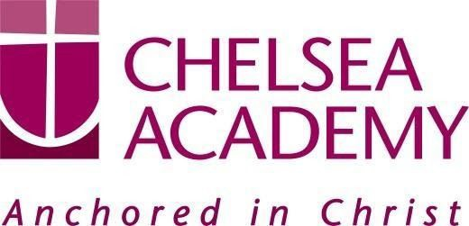
Chelsea Academy
Lots Road
London, SW10 0AB 1
T: 020 7376 3019 ex 146
E: admissions@chelsea-academy.org www.chelsea-academy.org

APPEAL AGAINST NO OFFER BEING MADE FOR A PLACE AT CHELSEA ACADEMY

Child’s first name |  | Child’s family name
Date of birth |  | Current school year
Last primary school attended
Address

Postcode
Parent/Carer’s name |  | Parent/Carer’s telephone number
Parent/Carer’s email address

Parent/Carer’s statement

(please continue overleaf if necessary)

Company No: 06176090 Principal: Mrs M Ardron

2

Chelsea Academy
Lots Road
London, SW10 0AB 3
T: 020 7376 3019 ex 146
E: admissions@chelsea-academy.org www.chelsea-academy.org

APPEAL GUIDANCE NOTES
If your child has not been offered a place at the school you wanted for him / her, you have the right to appeal against the decision under the 1998 School Standards and Frameworks Act. You can get more information on appealing in the School Admission Appeals Code (2022) available on the Department for Education website (www.education.gov.uk).

To appeal please complete and return this form, giving your reasons, within 20 school days from the date of the decision you are appealing against.

Appeals will be heard:
- For a Year 7 place, within 40 days of the published deadline
- For an in year admission, within 30 days of the appeal form being received
- For a sixth form place, within 30 school days of confirmation of exam results where the offer was conditional on those results. Where the offer was not conditional on results, the appeal will be heard within 40 school days of the appeal deadline date.
Your appeal will be heard by an independent panel made up of:
- lay people (someone without personal experience in the management of any school or provision of education in any school (except as a school governor or in another voluntary capacity));
- people who have experience or knowledge of education in the local authority area, or who are parents of registered pupils at school.
Please make sure you provide any supporting documents with your appeal form, for example medical reports, evidence of address etc. If you send in any supporting documents separately from your appeal form, please ensure these are clearly labelled with your child’s name and the name of the school you are appealing for. The deadline for submitting supporting documents will be five working days before the date of the appeal hearing. Any documents submitted after the deadline may not be considered by the Appeal Panel. The Panel have to make their decision based on the information they have before them. It is your responsibility to ensure that all the information relevant to your case is available to the Panel.

The appeal hearing will be organised by an independent School Appeals Panel service and they will be responsible for letting you know when and how appeal will be heard. You will be told at least 10 school days in advance of the date of the hearing.
Appeal hearings may be held either in person, or more usually online via video conference. You may take part with a friend or other representative. You will receive a copy of the evidence being submitted by Chelsea Academy to support their decision at least 7 working days before the hearing. If you do not attend the hearing either online or in person it will still be heard by the Panel and decided on the basis of your written evidence.

The Panel will try to make the proceedings as informal as possible, and will give you the opportunity to present your case, and any supporting evidence, and to ask questions. The Panel may also ask you questions and will examine the case made by Chelsea Academy, and may also question their representative. You will be informed of the Panel’s decision within a few days of the hearing.

Important note for Year 7 (secondary transfer) appeals:
If you are appealing for a Year 7 place we strongly advise you to accept any lower preference offer you may have received until you hear the outcome of your appeal.

THIS DOES NOT AFFECT YOUR RIGHT TO APPEAL NOR THE OUTCOME OF THE APPEAL.

Company No: 06176090 Principal: Mrs M Ardron

